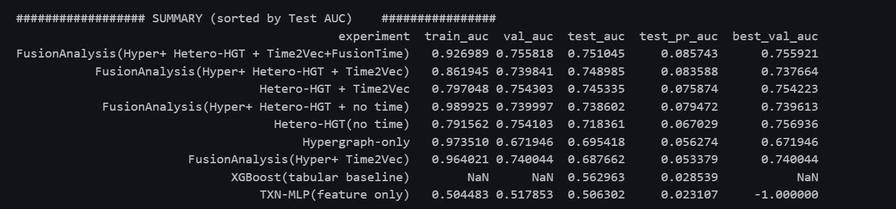

=================== OFFLINE RING STAGE(FULL FUSION ONLY ================
[RingStage] test_total =10,000 test_flagged=771 threshold =0.7
[ringStage] Using top_k flagged = 80

[RingScience] TP/FP counts:
group
FP 69
TP 11
Name: count, dtype: int64

[RingScience] Mann Whitney U tests(TP vs FP):
ring_consistency_score: U=390.0, p=0.8889
ring_density: U=398.0, p=0.8014
attr_type_entropy_novel: U=379.5, p=1
ring_fraud_rate: U=322.0, p=0.4258
pair_multi_attr_frac_novel: U=363.0, p=0.8231
My Novel Ring logic and Adaptive Budget summary
budget_K alpha_star P@K_fixed P@K_learned P@K_model_only P@K_ring_only gain R@K_fixed R@K_learned
25 0.00 0.1600 0.1600 0.1200 0.1600 0.0 0.363636 0.363636
50 0.08 0.1600 0.1600 0.1200 0.1200 0.0 0.727273 0.727273
100 0.00 0.1375 0.1375 0.1375 0.1375 0.0 1.000000 1.000000
200 0.00 0.1375 0.1375 0.1375 0.1375 0.0 1.000000 1.000000
500 0.00 0.1375 0.1375 0.1375 0.1375 0.0 1.000000 1.000000
[Novel Ring Logic] Spearman rho(K, alpha*)=-0.35355339059327373, p=0.5594043441634877

[RingStage] Investigation queue built
txn_id prob label ring_consistency_score score_combined rank_combined rank_model rank_ring
42130 0.944393 1 0.550620 0.826261 1 51 1
43451 0.971438 0 0.387719 0.796322 2 3 2
43371 0.971527 0 0.374890 0.792536 3 2 13
43331 0.969728 0 0.375055 0.791326 4 4 12
45347 0.964082 0 0.381381 0.789272 5 12 4
47120 0.960489 0 0.376914 0.785417 6 20 9
44383 0.952841 0 0.383220 0.781955 7 28 3
48378 0.952304 0 0.377488 0.779859 8 29 8
43178 0.942566 0 0.375666 0.772496 9 55 10
46981 0.959427 1 0.335271 0.772180 10 22 17

[RingStage] Budget comparison
budget precision@B_model precision@B_ring precision@B_combined recall@B_model recall@B_ring recall@B_combined
25 0.1200 0.1600 0.1200 0.272727 0.363636 0.272727
50 0.1200 0.1200 0.1200 0.545455 0.545455 0.545455
100 0.1375 0.1375 0.1375 1.000000 1.000000 1.000000
200 0.1375 0.1375 0.1375 1.000000 1.000000 1.000000
500 0.1375 0.1375 0.1375 1.000000 1.000000 1.000000
Saved: ring_metrics.csv
Saved: investigation_queue.csv
Saved: budget_compare.csv
Saved: Myadaptivebudgetlearnedalpha.csv

—------------------------

DBFraudecommerce.ipynb

HIDDEN_DIM = 128
OUT_EMB_DIM = 64
LR = 5e-4
EPOCHS = 40
SEED = 45
TRAINROWS = None ## if we select None here, then that would consider full dataset.
GRAPH_HOPS_FOR_RING = 2
RING_TXN_ID = 1234
THRESH = 0.80 # 0.7 #0.9
use_amp: bool = True
train_frac_time: float = 0.8

################## SUMMARY (sorted by Test AUC) ################
experiment train_auc val_auc test_auc test_pr_auc best_val_auc
FusionAnalysis(Hyper+ Hetero-HGT + Time2Vec) 0.916505 0.775448 0.750067 0.132735 0.775575
FusionAnalysis(Hyper+ Hetero-HGT + no time) 0.886335 0.774571 0.745943 0.125083 0.774485
Hetero-HGT + Time2Vec 0.775707 0.745962 0.740042 0.105616 0.746349
Hypergraph-only 0.889538 0.758321 0.728903 0.113601 0.758321
Hetero-HGT(no time) 0.784943 0.750198 0.724421 0.107042 0.750203
XGBoost(tabular baseline) NaN NaN 0.634970 0.055133 NaN
TXN-MLP(feature only) 0.468689 0.476909 0.463872 0.031975 -1.000000

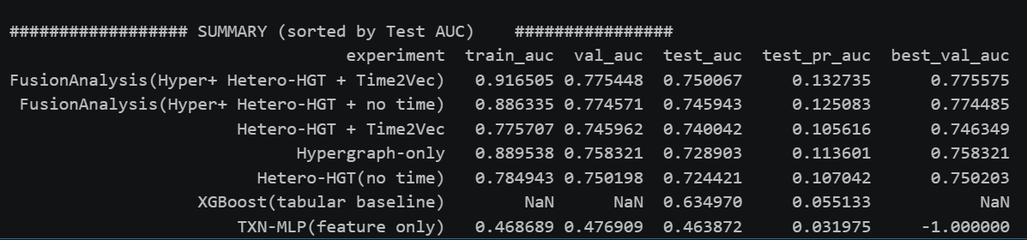

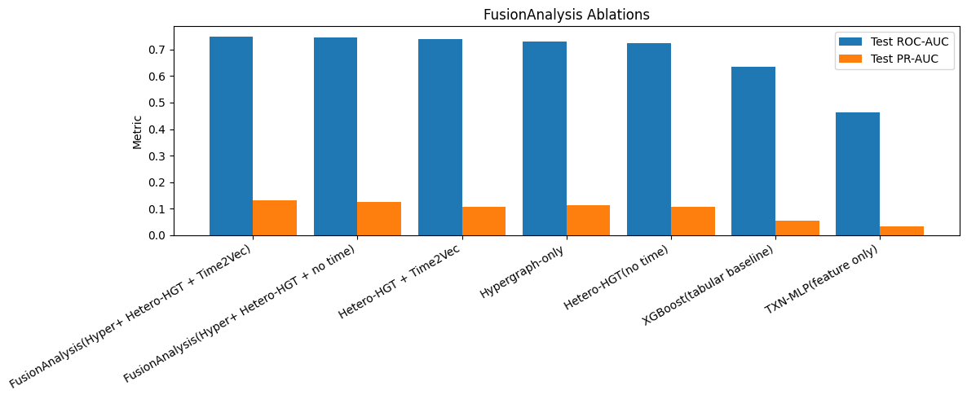

################## SUMMARY (sorted by Test AUC) ################
experiment train_auc val_auc test_auc test_pr_auc best_val_auc
FusionAnalysis(Hyper+ Heterogeneous + Time2Vec) 0.935972 0.780485 0.751380 0.122617 0.780457
FusionAnalysis(Hyper+ Heterogeneous + no time) 0.847365 0.770970 0.748598 0.130907 0.770963
Heterogeneous(no time) 0.767341 0.746042 0.726085 0.106453 0.746326
Hypergraph-only 0.918874 0.762435 0.721923 0.115000 0.762435
Heterogeneous + Time2Vec 0.782840 0.744451 0.719261 0.106673 0.743938
XGBoost(tabular baseline) NaN NaN 0.634970 0.055133 NaN
TXN-MLP(feature only) 0.468689 0.476909 0.463872 0.031975 -1.000000

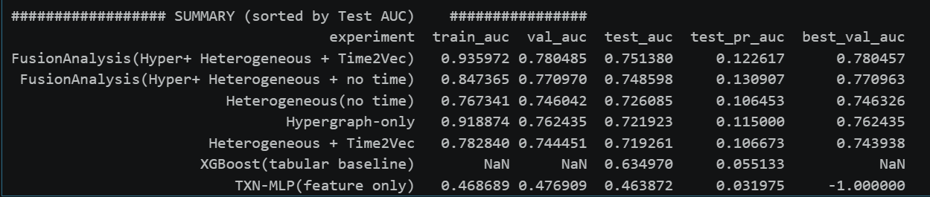

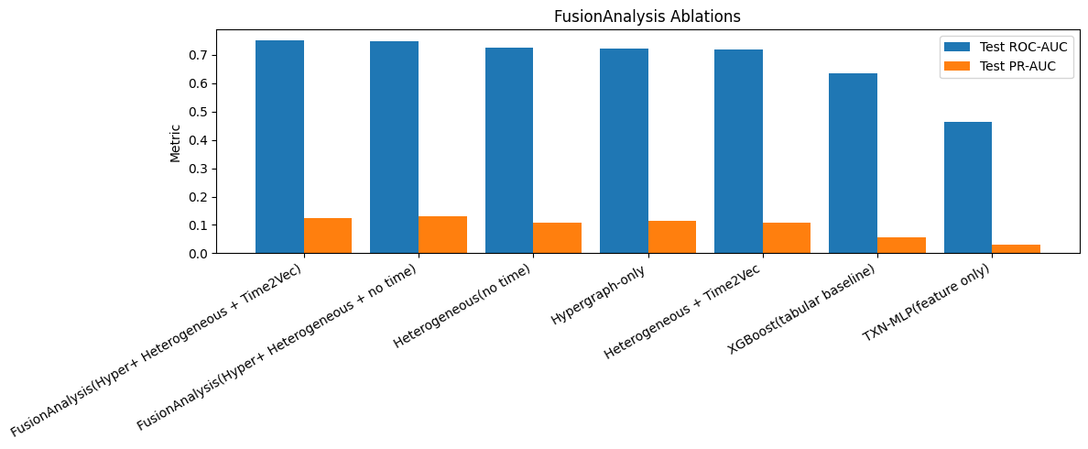

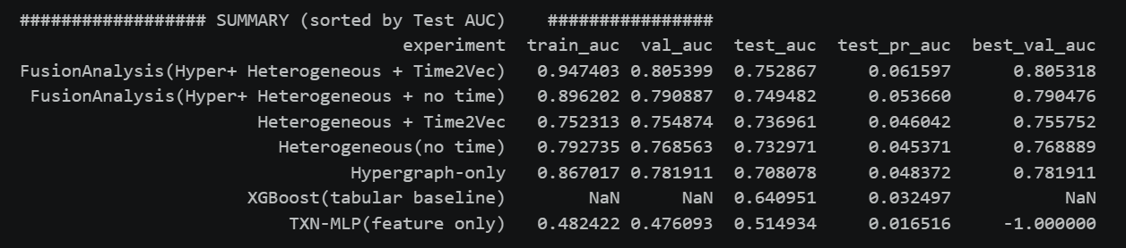

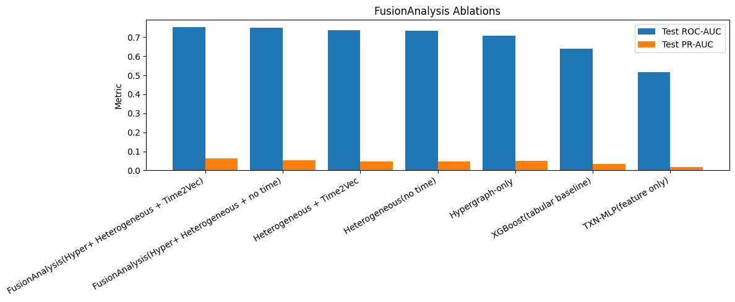

=================== OFFLINE RING STAGE(FULL FUSION ONLY ================
[RingStage] test_total =9,000 test_flagged=1,676 threshold =0.8
[ringStage] Using top_k flagged = 100

[RingScience] TP/FP counts:
group
FP 71
TP 29
Name: count, dtype: int64

[RingScience] Mann Whitney U tests(TP vs FP):
ring_consistency_score: U=971.0, p=0.6595
ring_density: U=1103.0, p=0.5792
attr_type_entropy_novel: U=1029.5, p=1
ring_fraud_rate: U=991.0, p=0.7728
pair_multi_attr_frac_novel: U=960.0, p=0.6002
My Novel Ring logic and Adaptive Budget summary
budget_K alpha_star P@K_fixed P@K_learned P@K_model_only P@K_ring_only gain R@K_fixed R@K_learned
25 0.50 0.32 0.32 0.28 0.24 0.00 0.275862 0.275862
50 0.74 0.38 0.40 0.36 0.24 0.02 0.655172 0.689655
100 0.00 0.29 0.29 0.29 0.29 0.00 1.000000 1.000000
200 0.00 0.29 0.29 0.29 0.29 0.00 1.000000 1.000000
500 0.00 0.29 0.29 0.29 0.29 0.00 1.000000 1.000000
[Novel Ring Logic] Spearman rho(K, alpha*)=-0.7826237921249264, p=0.11761376087345808

[RingStage] Investigation queue built
txn_id prob label ring_consistency_score score_model score_ring score_combined rank_combined rank_model rank_ring
36154 0.994360 1 0.385134 0.994862 0.465482 0.941414 1 2 18
36522 0.993587 0 0.385206 0.980629 0.465683 0.937374 2 3 17
44132 0.992303 0 0.383769 0.956998 0.461681 0.907071 3 6 20
37052 0.989448 0 0.385340 0.904460 0.466056 0.893939 4 10 15
38192 0.983867 0 0.384216 0.801740 0.462927 0.839394 5 16 19
44383 0.983835 0 0.383220 0.801150 0.460154 0.826263 6 17 21
41044 0.984583 1 0.379886 0.814922 0.450875 0.825253 7 15 26
37009 0.979540 0 0.385272 0.722095 0.465866 0.813131 8 21 16
39531 0.979410 0 0.381517 0.719705 0.455415 0.784849 9 22 23
42462 0.977443 1 0.388339 0.683509 0.474403 0.762626 10 29 14

[RingStage] Budget comparison
budget precision@B_model precision@B_ring precision@B_combined recall@B_model recall@B_ring recall@B_combined
25 0.28 0.24 0.28 0.241379 0.206897 0.241379
50 0.36 0.24 0.40 0.620690 0.413793 0.689655
100 0.29 0.29 0.29 1.000000 1.000000 1.000000
200 0.29 0.29 0.29 1.000000 1.000000 1.000000
500 0.29 0.29 0.29 1.000000 1.000000 1.000000
Saved: ring_metrics.csv
Saved: investigation_queue.csv
Saved: budget_compare.csv
Saved: Myadaptivebudgetlearnedalpha.csv

